ResearchHub AI – Smart Research Paper Discovery, Summarization, and Workspace Assistant

Project Description:

With the exponential growth of academic research publications and the increasing complexity of staying current with scientific literature, researchers often struggle to efficiently discover, organize, and analyze relevant research papers. Traditional methods of paper management involve manual searching, downloading, organizing, and reading through extensive literature, which is a time-consuming process that reduces research productivity. To address this challenge, ResearchHub AI was developed as an intelligent, agentic AI-powered research paper management platform.
The system also includes organized workspaces, AI tools for document analysis, PDF upload support, and a Doc Space for storing generated summaries, extracted notes, and AI-generated analysis reports. By combining paper discovery, intelligent analysis, conversational assistance, and structured document management into a single system, ResearchHub AI acts as a smart academic companion for students, researchers, and professionals.
Scenario 1: Smart Research Discovery and Paper Understanding
ResearchHub AI can be used as an intelligent research discovery and reading assistant for students, faculty, and researchers who need to handle large volumes of academic literature. Instead of manually searching different sources and reading papers one by one, users can search for relevant research papers, upload their own PDF documents, and bring all important material into a single workspace. The system then helps them quickly understand the content by generating summaries, extracting key insights, and answering research-related questions through an AI-powered assistant. This reduces the time spent on manual literature exploration and improves the speed and quality of research work.
Scenario 2: AI-Powered Research Analysis and Writing Support
ResearchHub AI can also serve as an AI-powered research analysis and writing support system for users who need more than just paper collection. After papers are added into the platform, the system can study their content and help users extract important findings, compare ideas across multiple papers, generate structured summaries, and assist in preparing literature review material. It can also support question answering, note generation, and document-focused analysis inside the workspace. This makes the platform useful not only for discovering research, but also for understanding, organizing, and converting research content into meaningful academic output with less manual effort.

Scenario 3 Workspace-Based Research Organization and Knowledge Management

ResearchHub AI can be used as a centralized workspace for managing research knowledge in an organized and reusable way. Users can create separate workspaces for different subjects, projects, or domains and store research papers, uploaded PDFs, summaries, extracted notes, and AI-generated outputs in one place. Instead of keeping information scattered across folders, websites, and personal notes, the platform brings everything together in a structured environment. This helps users track their reading, revisit important findings, manage research material efficiently, and build a more systematic knowledge base for long-term academic or professional work.

Architecture:
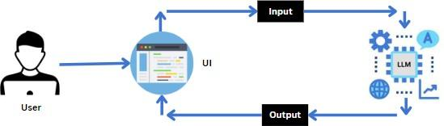

Project Flow:
- Users first enter the platform and access their personal research workspace, where they can organize and manage their research activities. Within this workspace, users can search for relevant research papers, upload their own PDF documents, and collect useful papers related to their study topics.
- Once the papers are added, the system processes the content and provides several AI-powered features such as automatic summarization, extraction of key insights, question answering, and assistance in understanding complex research material. These capabilities help users quickly grasp the main ideas of research papers without manually reading every section.
- The system also allows users to interact with an AI assistant that can answer questions based on the selected research documents and workspace context. All uploaded papers, generated summaries, extracted notes, and AI analysis results are stored within the workspace so that users can revisit them anytime, making the research process more organized and efficient.

Prior Knowledge:
You must have prior knowledge of the following topics to complete this project.
• Large Language Models (LLM) and AI APIs
A Large Language Model (LLM) is an advanced artificial intelligence system trained on large volumes of text data to understand, analyze, and generate human-like responses. In this project, AI models are used to analyze research documents, generate summaries, answer questions, and assist users in understanding academic papers. Understanding how AI models process text inputs, generate responses, and support conversational interactions is important for implementing intelligent research features. Examples of widely used AI models include GPT models, Gemini models, and other modern generative AI systems that support text understanding and analysis.

• Frontend Development (React, HTML, CSS)
Knowledge of frontend development is required to build the user interface of the platform. Technologies such as HTML, CSS, and React are used to design interactive and responsive web interfaces where users can search for research papers, upload documents, interact with AI assistants, and manage workspaces. Understanding component-based architecture, user input handling, and data rendering is essential for building a smooth and user-friendly experience.
https://react.dev/
https://vitejs.dev/
• Backend Development with Python (FastAPI / Flask)
Backend development knowledge is necessary for creating APIs that connect the frontend interface with AI services and document processing systems. Python frameworks such as FastAPI or Flask can be used to handle requests, process research documents, manage data flow, and integrate AI-powered features. Understanding how to design REST APIs, handle JSON data, and manage server-side logic is important for implementing the core functionality of the research assistant platform.
https://fastapi.tiangolo.com/
• AI Integration and Prompt Processing
Basic understanding of integrating AI services into applications is important. This includes sending prompts to AI models, receiving responses, and using those responses to perform tasks such as document summarization, key insight extraction, and question answering. Managing API keys, handling model outputs, and structuring prompts correctly are important parts of AI-powered systems.
• Document Processing and PDF Handling
Knowledge of handling research documents such as PDF files is required in order to upload, read, and process research papers. Understanding how to extract text from documents, analyze the content, and store useful information helps in building features such as summarization, document analysis, and AI-based interaction with research papers.

Project Structure:
Create the Project folder which contains application file as shown below
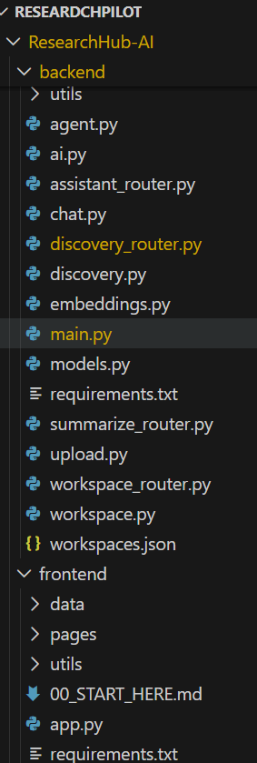

Milestone 1: Requirements Specification
Adding all the needed libraries in the requirements.txt file makes it easy to set up and run the project. It helps others install the same dependencies and avoid errors while working or deploying the project.

Activity 1: Create a requirements.txt file to list the required libraries.

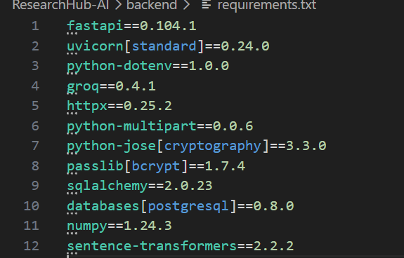

Activity 2: Install the required libraries.

Milestone 2: Initializing the Model

For initializing the model we need Groq API.

Activity 1: Generate Gemini API

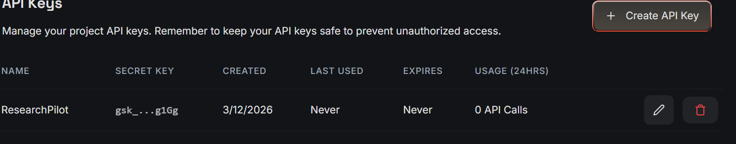

Click on the link
(https://console.groq.com/keys)
- Now click on “Create API key”. (Refer the above image)
- Copy the API key.

Activity 2: Initialize the pre-trained model

Activity 2.1: Import the Groq module and dotenv modules

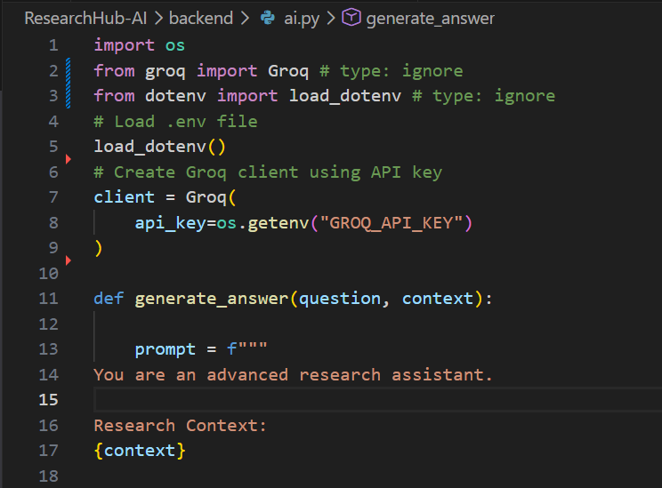

- The load_dotenv() function loads environment variables from the .env file, ensuring secure access to sensitive data like API keys used later in the application.

Activity 2.2: Configuration of the Gemini API:
Configuring the API key:
The configure function is used to set up or configure the Gemini API with an API key. The provided API key, in this case, is " and it should be placed in “.env” file.

Activity 2.3: Define the model to be used:

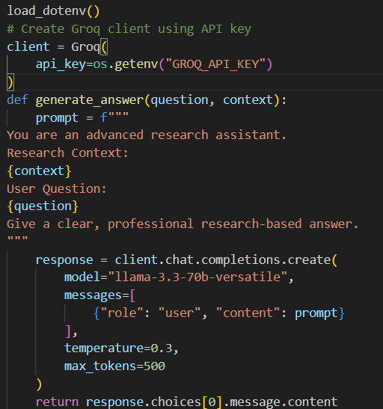

- Generation Settings:
This code defines the AI model used in the application by initializing the Groq client with the API key from the .env file.
It creates a generate_answer() function that takes the user’s question and research context as input.The function sends a structured prompt to the LLaMA 3.3 70B Versatile model to generate a research-based response.Finally, it returns the generated answer for use in the application.

Milestone 3 – Backend Development

This milestone implements the FastAPI backend APIs for handling document uploads, semantic search, research assistance, summarization, and workspace management.

Activity1: Upload module
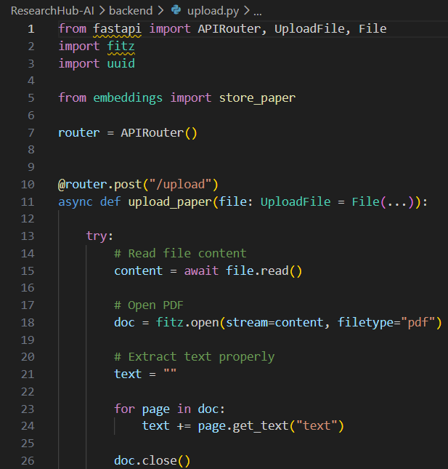

- This file handles PDF upload and text extraction from research papers.
It reads the uploaded paper content and prepares it for further processing.
This is the entry point for adding papers into the system.
Activity 2: backend/embeddings.py
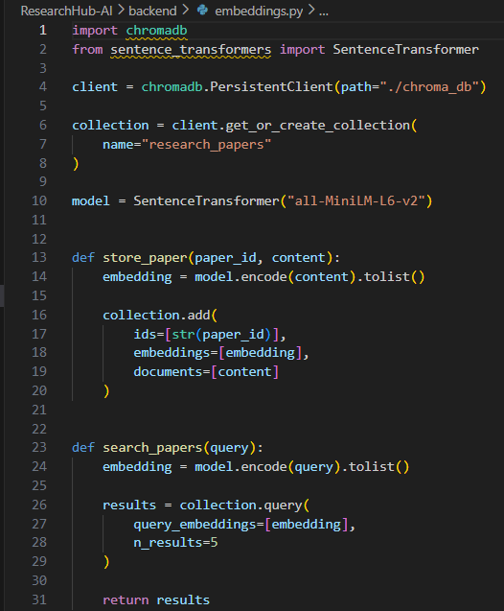

- This file generates vector embeddings for extracted paper text using Sentence Transformers.It stores and retrieves embeddings from ChromaDBfor semantic search.This enables similarity-based paper search in the system.

Activity 3: backend/chat.py

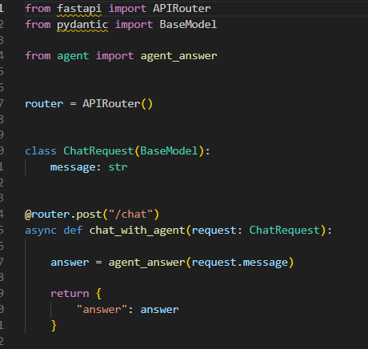

- This file provides the backend logic for chatting with uploaded research papers.It accepts user questions and returns AI-generated answers based on aper content.This supports interactive paper understanding.
Activity 4: Discovery of the Papers

Activity 4.1: backend/discovery.py

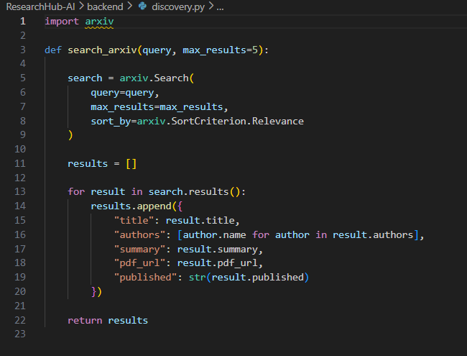

This file handles paper discovery features by fetching research paper data from external sources like arXiv.It helps users find relevant papers based on topics or keywords.This expands the system beyond uploaded documents.

Activity 4.2: backend/discovery_router.py

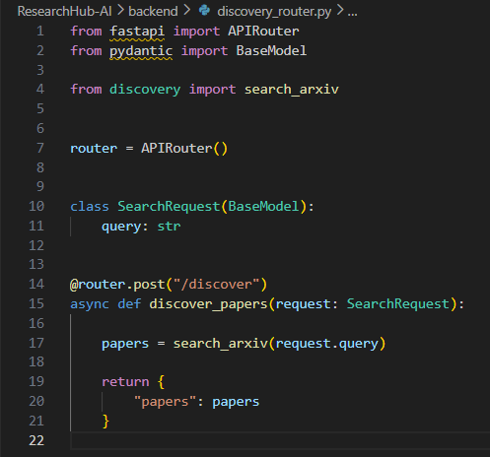

This file exposes API routes for the discovery module.
It connects frontend requests with the discovery logic.
This allows users to search and retrieve external research papers.

Activity 5 : backend/summarize_router.py

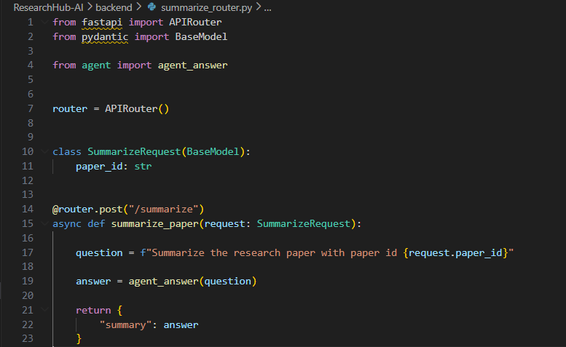

This file provides API endpoints for research paper summarization.
It sends paper content to the AI model and returns concise summaries.
This helps users quickly understand papers.

Activity 6: backend/assistant_router.py

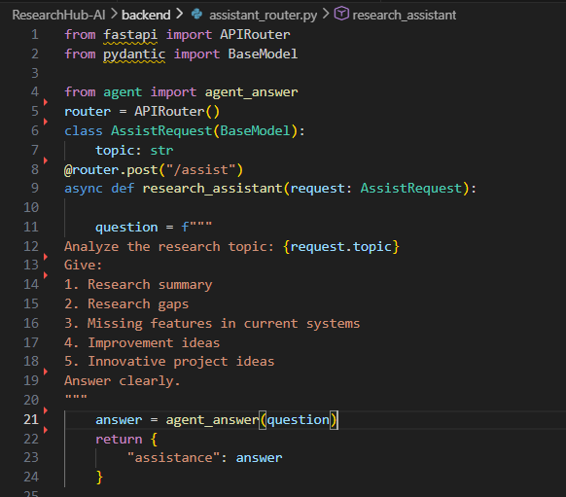

This file provides API routes for the research assistant feature.
It accepts research-related queries and returns guided AI responses.
This supports idea generation, gap finding, and question answering.

Activity 7: Workspace
Activity 7.1: backend/workspace.py
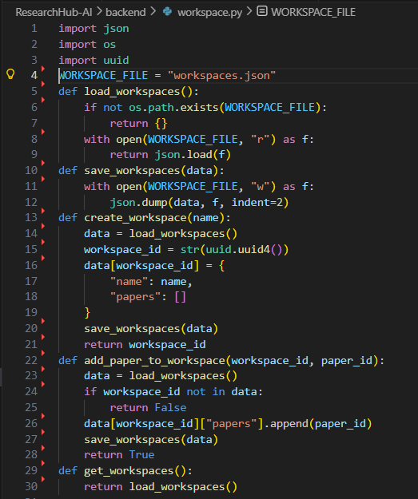

This file manages workspace-related operations such as organizing papers and saving workspace data.
It helps structure research materials into separate collections.
This improves project organization inside the system.
Activity7.2: backend/workspace_router.py

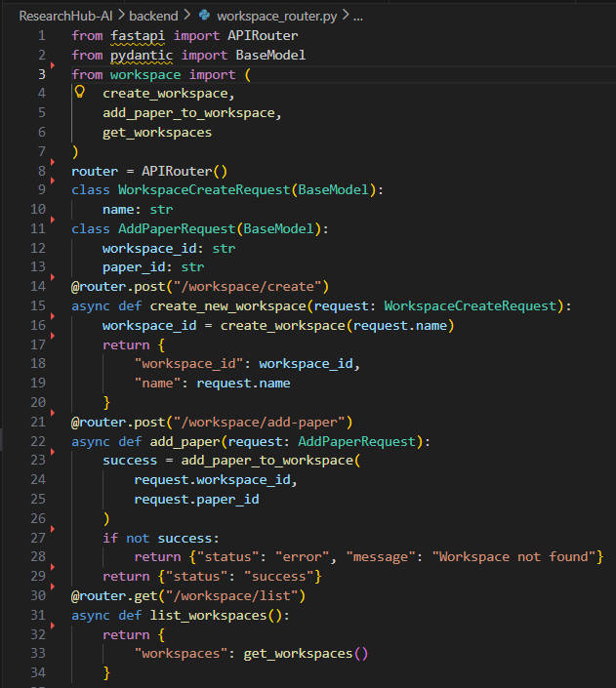
This file exposes API endpoints for workspace creation and management.
It connects the workspace logic to frontend actions.
This allows users to manage research workspaces interactively.
Activity 8: backend/main.py
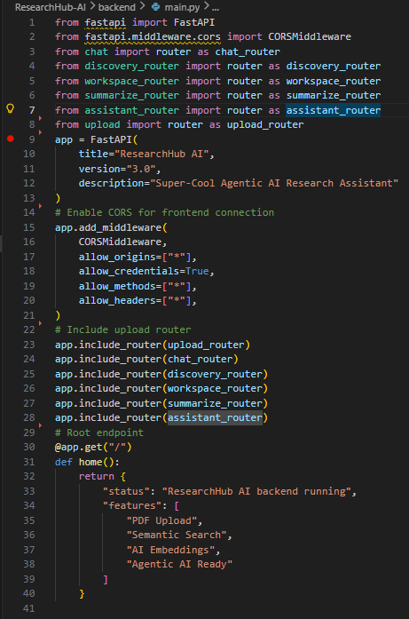
This is the main FastAPI application file.
It initializes the backend server and includes all required routers.
This file integrates all backend modules into one running API system

Milestone 4: Frontend Development
The frontend is built using Streamlit, which provides an interactive interface for uploading research papers, querying AI models, discovering papers, and organizing research workspaces.

Activity 1: frontend/app.py

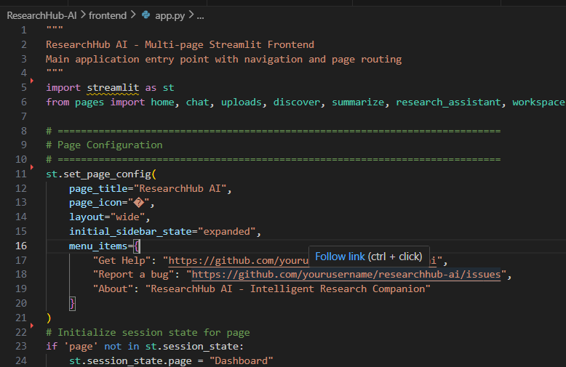
This is the main Streamlit entry file of the application.
It sets page configuration, initializes session state, and manages navigation between pages.This file acts as the main frontend controller.

Activity 2: frontend/pages/home.py

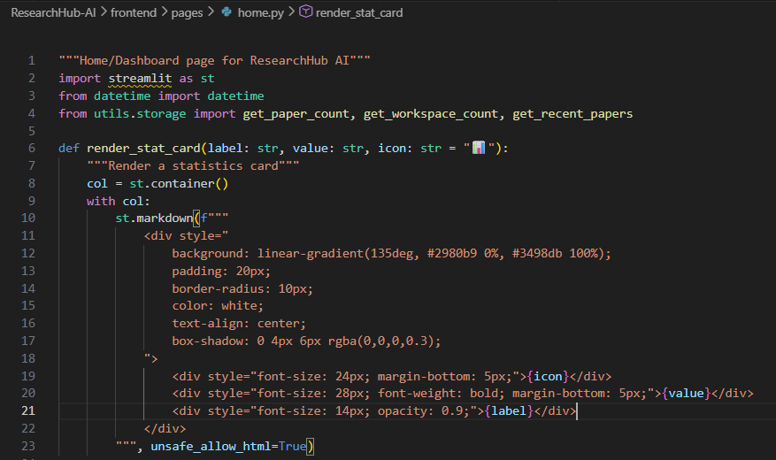

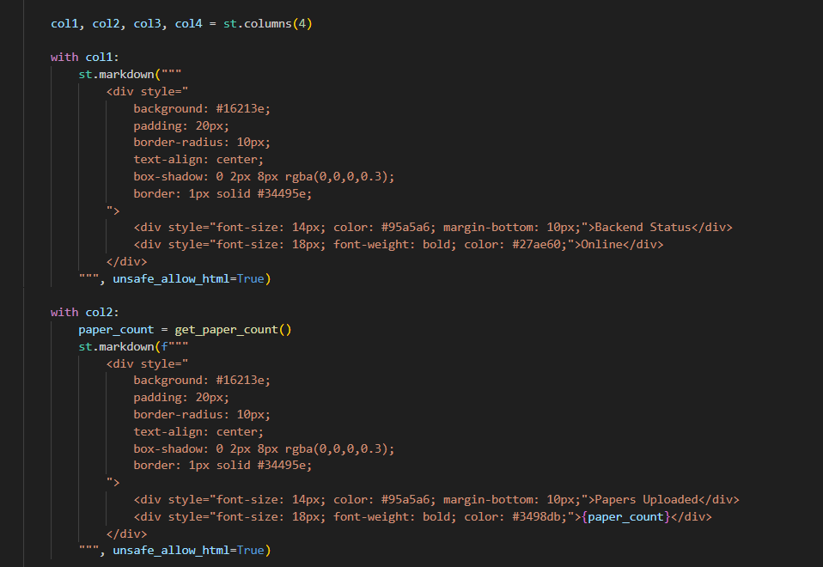

This file implements the dashboard or home page of the system.
It displays project title, statistics, and overview details of uploaded papers or workspaces.This gives users a summary view of the application.

Activity 3: frontend/pages/uploads.py:

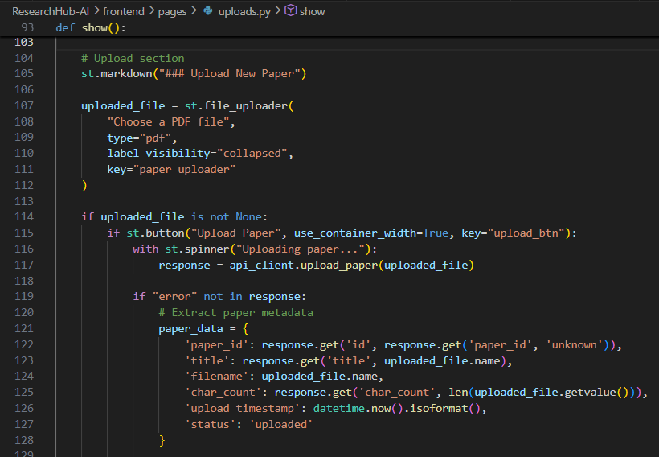

This file provides the user interface for uploading research papers.
It sends selected PDF files to the backend for extraction and storage.
This page is used to add new papers into the system.

Activity 4: frontend/pages/chat.py
` 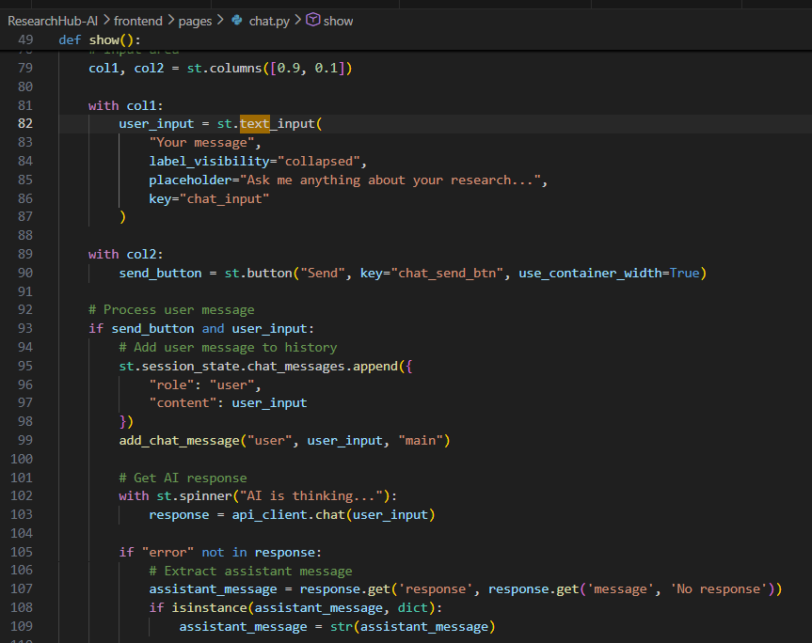

This file implements the chat interface for interacting with research papers.
It accepts user questions and displays AI-generated responses from the backend.
This enables conversational understanding of uploaded papers.

Milestone 5: System Execution & Output

Activity1: Backend running

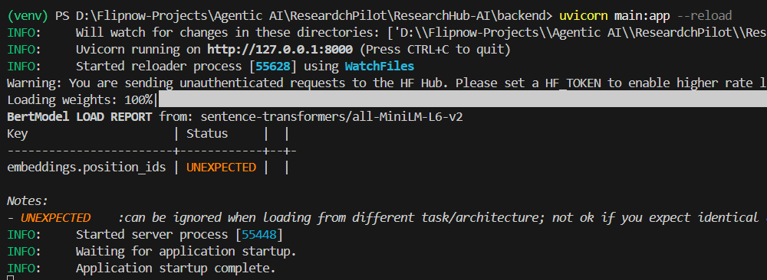

Activity 2: Frontend running
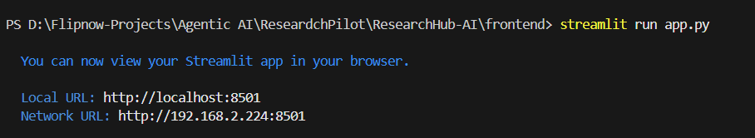

Activity 3: Home Dashboard

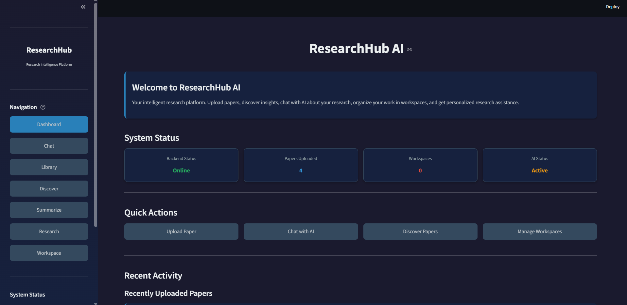

Activity 4: Upload paper

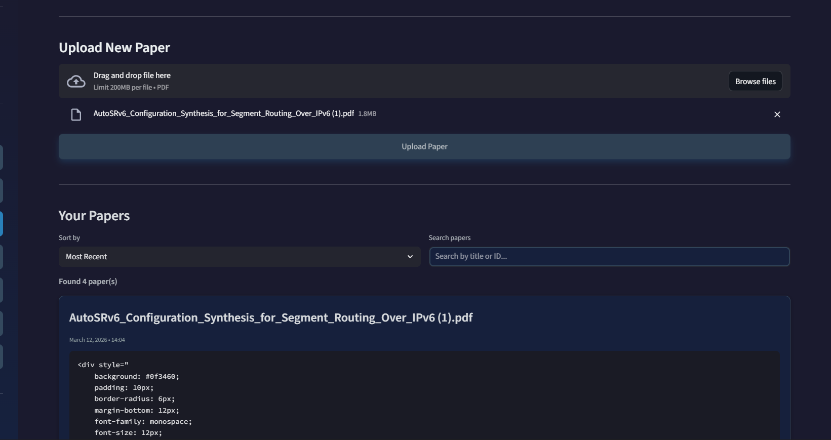

Activity 5: Chat with AI

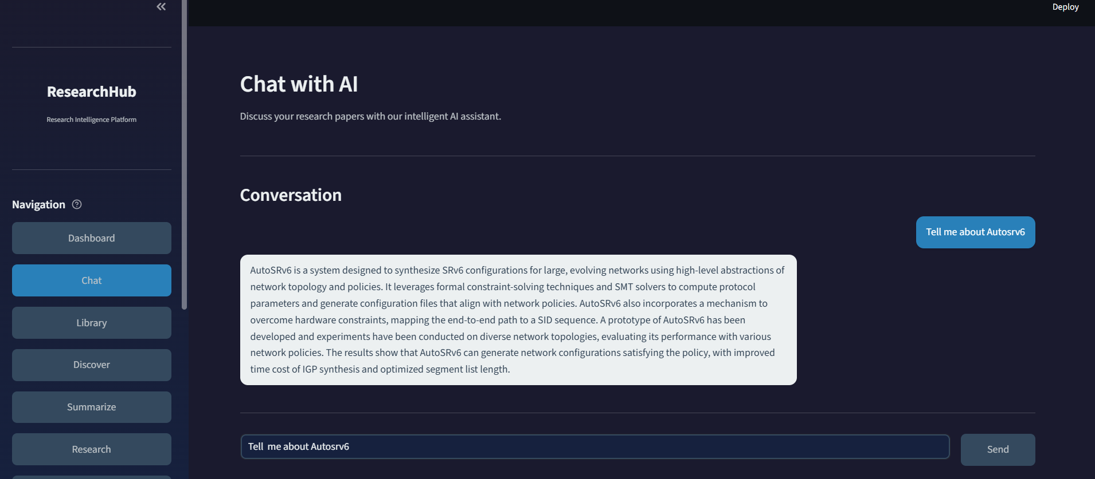

Activity 5: Discover papers

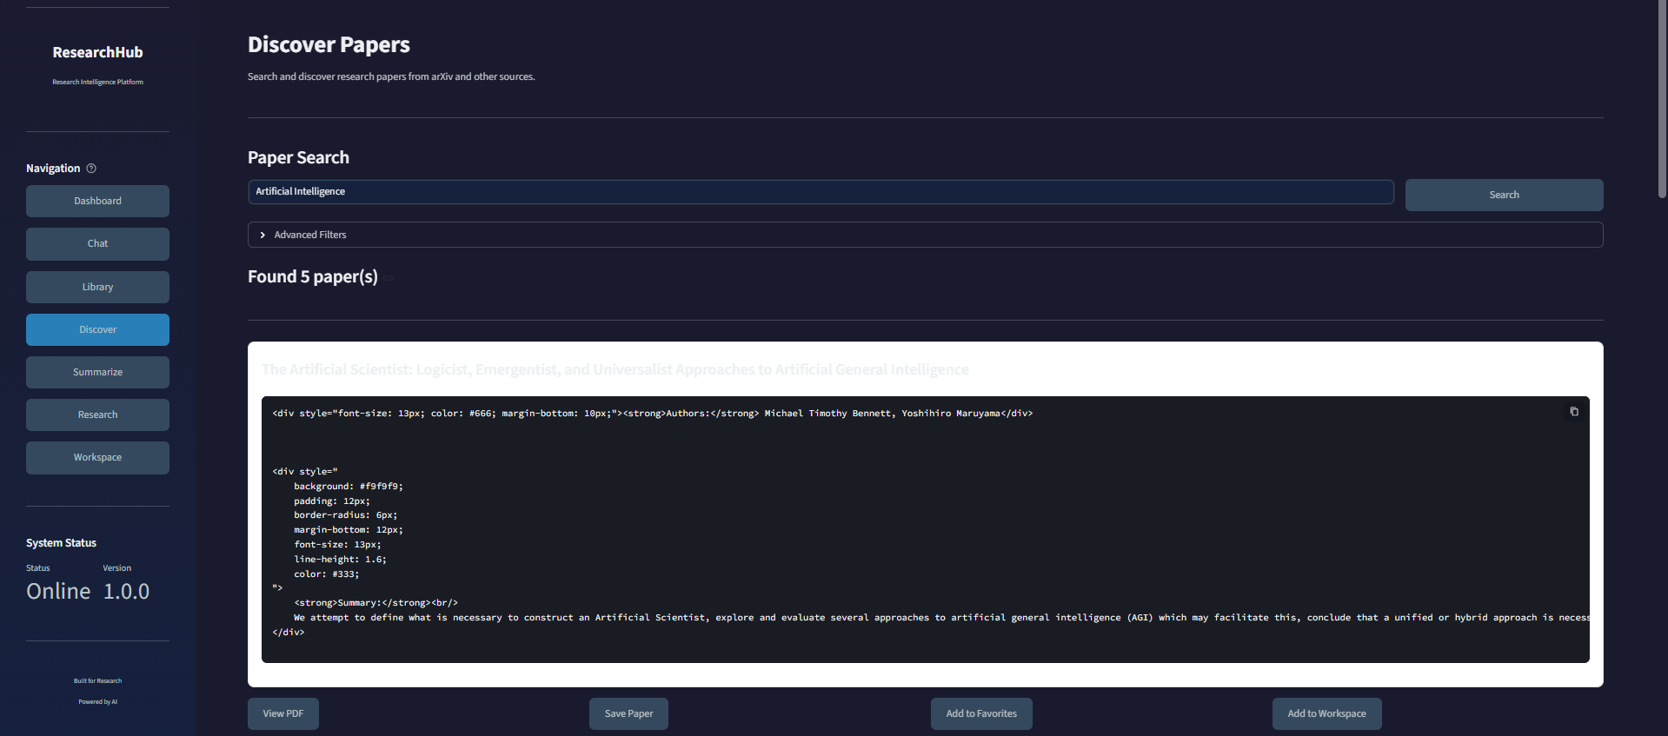

Activity 6: Workspaces

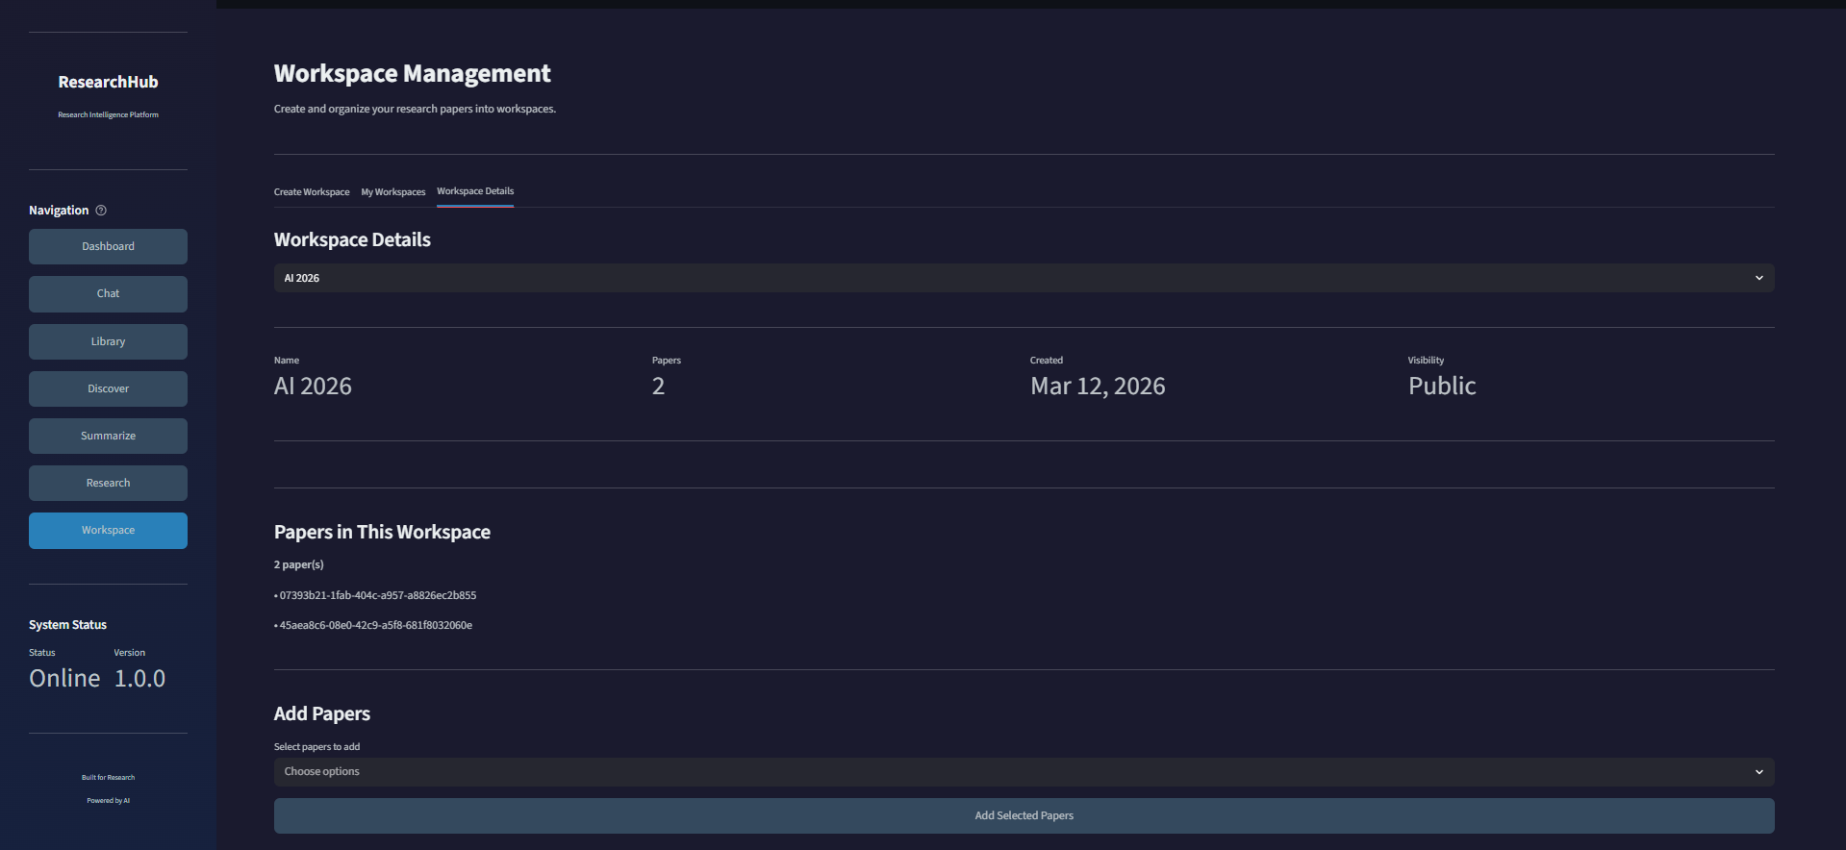
Activity 7: Summarize Paper

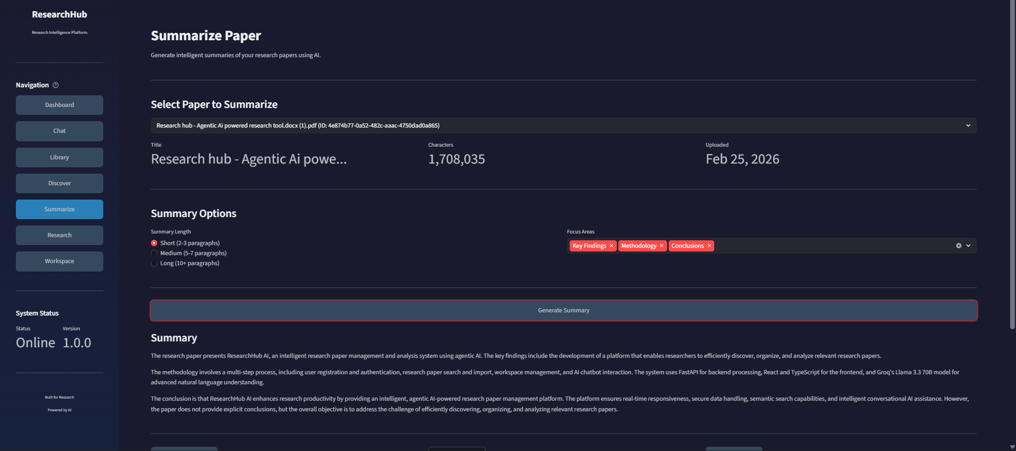
Conclusion
The ResearchHub AI system successfully demonstrates an intelligent platform for managing and analyzing research papers using modern AI technologies. The system integrates a FastAPI backend with a Streamlit-based interactive frontend to provide a seamless research experience. By incorporating large language models through the Groq LLaMA API, the platform enables users to interact with research papers through natural language queries, generate summaries, and obtain research assistance.
The project allows users to upload research papers, discover relevant publications from external sources, generate AI-driven summaries, and organize papers into structured workspaces. These features improve research efficiency by helping users quickly understand complex academic material and manage large collections of papers. The modular architecture ensures scalability and allows future integration of advanced features such as improved semantic search, collaborative workspaces, and deeper knowledge extraction.
Overall, the ResearchHub AI platform demonstrates how artificial intelligence can significantly enhance research wor kflows by automating information retrieval, summarization, and knowledge organization. The system provides a foundation for building more advanced research intelligence tools that support scholars, students, and professionals in navigating the rapidly growing volume of academic literature.

